Initially Decreasing Data

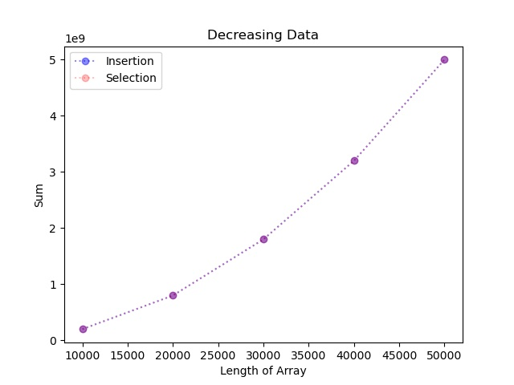

These lines are shaped much more similarly than they are in the initially increasing set. This is because a decreasing set of data is the worst-case scenario for both the insertion sort and the selection sort. This is the worst-case scenario for insertion sort since the order is completely opposite oriented to how the array should be, and since the sort works by individually switching consecutive elements if they need to, and it takes much more for initially increasing data, which leads to much longer runtime. Since selection sort is always running at close to worst-case scenario, and insertion sort is running at its worse-case scenario in this scenario, which leads to similar runs.